Fall 2020
AP US Government
Seim Name ______________________________________

Using your textbook, notes, the attached chart, the article from New York Magazine, and any independent research you would like to add, answer the following FRQ discussing bureaucracy and the Coronavirus.

Bureaucracy

- The federal bureaucracy as part of the executive branch exercises substantial independence in implementing governmental policies and programs.
  - Most workers in the federal bureaucracy are civil-service employees who are organized under a merit system.
    - Describe one key characteristic of the merit system.
    - Describe general level of experience and expertise bureaucrats compared to legislators
    - Identify and describe the process of hiring a cabinet-level secretary position.
    - Explain how that process is similar or different from the process of hiring most bureaucrats.
  - Examine the chart below
    - What is the relationship between the Secretary of Health and Human Services and the Center for Disease Control?
    - Describe one feature of bureaucracy that is illustrated by the chart below.
  - Explain how the differences in hiring, qualifications and accountability that could lead to the actions and statements by
    - the Secretary of Health and Human Services
    - the Centers for Disease Control
    - the President of the United States

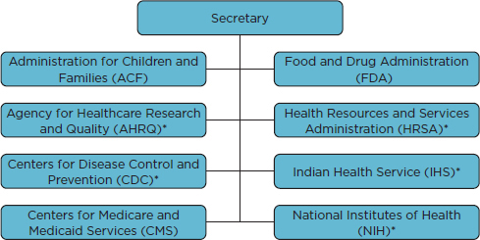
CORONAVIRUS MAR. 8, 2020

Trump Administration Reportedly Overruled CDC Advice for Seniors Not to Fly
By Matt Stieb
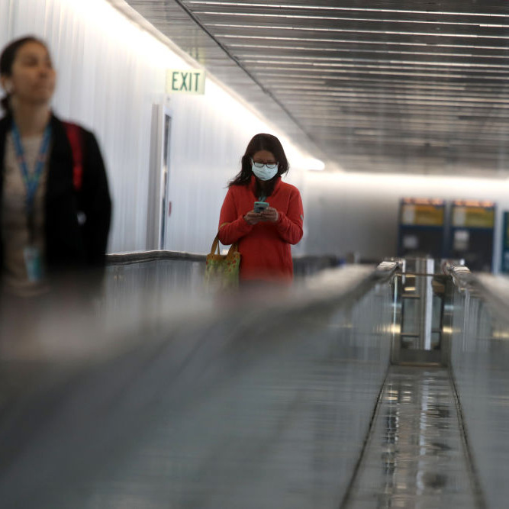
The international terminal at the San Francisco airport on Friday. Photo: Justin Sullivan/Getty Images
As the federal government moves from a strategy of containment to one of mitigation, the Trump administration’s mismanagement of the coronavirus continues to escalate. The most concerning report over the weekend involved the White House’s decision, according to one federal official who spoke with the Associated Press, to override the Centers for Disease Control and Prevention’s recommendation that elderly and immunosuppressed Americans should not fly in order to avoid potential exposure to COVID-19.
Administration officials have since suggested that vulnerable groups like the elderly avoid “large crowds” and “long trips,” but have not come around to the CDC’s full recommendation. The move, which the White House denied, appears to be in line with Trump’s attempts to downplay the crisis in order to limit its economic and electoral impacts — including his erroneous claim that the downturn in international travel would be good for the American economy. During his visit to the CDC on Friday, Trump told reporters that he did not want to bring 21 infected passengers on a Grand Princess cruise ship off the coast of California “because I like the numbers being where they are,” referring to the number of confirmed cases on U.S. soil. Health officials, however, told Vice-President Mike Pence that uninfected passengers should be removed from the ship to avoid infections that would likely occur in its close quarters. (Trump ultimately gave in, and the passengers will disembark on Monday, to be treated and tested by state health officials.)
According to administration officials, much of the White House’s slow response to combat the virus can be traced to the president’s tendency to prioritize information that makes him look good, and the crisis look more manageable than it is. “It’s a clearly difficult situation when the top wants to hear certain answers,” one former official who’s briefed the White House told Politico. “That can make it difficult for folks to express their true assessment — even the most experienced and independent minds.”
The administration is also reportedly pushing their sunny-day approach on officials at the CDC, according to the Washington Post. In Senate testimony on February 13, Health and Human Services Secretary Alex Azar said that the “CDC has begun working with health departments in five cities to use its flu surveillance network” to begin coronavirus testing. According to the Post, the CDC disagreed:
When Azar’s team had sent his prepared remarks to the Centers for Disease Control and Prevention before delivery, the agency pushed back and urged him to soften his language. State health departments had not yet been informed of the plans — and were certain to be upset by them — and the coronavirus test kits contained a faulty component that caused a spike in inconclusive results. Azar announced the plans anyway, in part because “it would be really valuable for him [to] have the news,” as one HHS official put it in an internal email.
Meanwhile, the status of coronavirus testing continues to be a nightmare: On Saturday, federal officials announced they do not know how many Americans have been tested, while on Friday The Atlantic was only able to confirm 1,895 tests nationally. “The CDC got this right with H1N1 and Zika, and produced huge quantities of test kits that went around the country,” Thomas Frieden, the director of the CDC from 2009 to 2017, told The Atlantic. “I don’t know what went wrong this time.” Among the things that went wrong in the roll-out so far: the distribution of faulty testing kits; a reported contamination at a CDC lab; severe testing restrictions that allowed for undetected spread of the virus; and the unforced error of deciding to create (and wait for) tests rather than distribute those provided by the World Health Organization.
Between his public appearances spouting misinformation, Trump hasn’t been able to maintain his focus: During a meeting in late January, HHS Secretary Azar was reportedly unable to keep his attention, as Trump annoyed him about the agency’s vaping ban. This weekend — as Italy attempted to quarantine 16 million people, the State department advised against cruise travel, and the U.S. death toll reached 21 — Trump spent two days golfing in Florida.

